ANC DAK and Code4HealthHackton transforming digital health systems in SL
Title of case study: Sierra Leone Lays the Foundation to Digital Health Transformation Through SMART Guidelines, Digital Public Goods and Youth Innovation
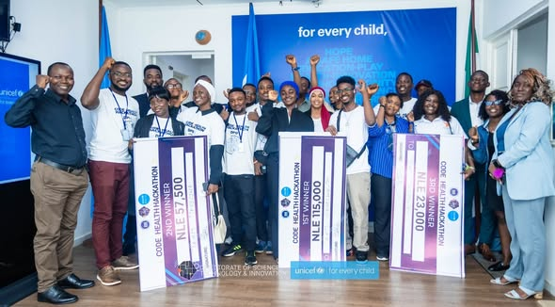 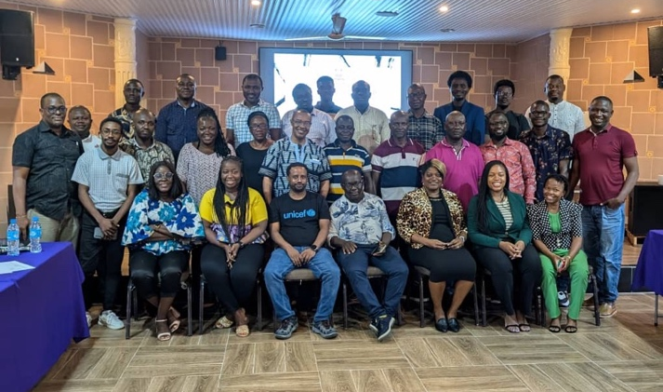
Case study captured by: Agazi Ameha (HSS Specialist), Banglie Lamin (M&E Specialist), Health and Nutrition Officers (Diana Mbaindu Koroma; Ibrahim Salim Kamara and Mohamed Juana), with contributions from Bani Christopher Forster and Alpha Amadu Barrie.
Reviewed by: Dr. Vandana Joshi (Chief Health, Nutrition HIV), James Houghton (Innovation Manager)
Sierra Leone is advancing efforts to modernize its health system by placing digital innovation at the center of improving maternal and newborn health outcomes. Through the implementation of the World Health Organization (WHO) SMART Guidelines for Antenatal Care (ANC)- the first contact of pregnant women to health system, the country is transitioning from fragmented, paper-based systems to standardized, interoperable digital solutions that strengthen service delivery nationwide. This initiative was possible with funding from German Government (GIZ) through Digital Innovation Pandemic Control (DIPC) project which supported the DAK adaptation process and Digital Public Goods (DPG) Fund financing from NORAD that supported the Code4Health Hackathon, the efforts helped strengthen local digital capacity while advancing national health priorities.
For years, the health sector faced challenges with fragmented digital systems and heavy reliance on manual processes, particularly in antenatal care. Paper-based registers limited timely decision-making, weakened referral systems, and made it difficult to track high-risk pregnancies effectively. In response, the Ministry of Health (MOH) and in collaboration with the Ministry of Communication, Technology and Innovation (MoCTI) and its Directorate of Science, Technology and Innovation (DSTI), with support from UNICEF, including technical and programme leadership from both the Health and Innovation teams, adopted the WHO SMART Guidelines approach to translate clinical guidance into structured digital standards.
The transformation began in September 2024 with the country-led adaptation of the ANC Digital Adaptation Kit (DAK), which converted national ANC guidelines into standardized workflows, data elements, and system requirements. This established a shared national digital standard, reduced fragmentation, and strengthened governance of digital health investments while aligning innovations with national priorities.
Building on this foundation, the government launched the Code4Health Hackathon in January 2025, engaging 22 young Sierra Leonean developers across five teams. Working with clinicians and digital health experts, they translated these standards into functional digital public good prototypes aligned with interoperability requirements. The hackathon produced three key solutions: Geneline-X App for integrated care coordination, Healthy Mother App for pregnancy guidance and reminders, and Medikated Platform for digital pharmacy and consultation services. These solutions demonstrate how Digital Public Goods can move beyond concept to practical implementation, supporting scalable, interoperable systems that respond directly to country needs.
This initiative demonstrates how structured innovation can strengthen collaboration between the health and technology sectors, while building a foundation for interoperable, scalable national digital public infrastructure built by local digital capacity, and promote youth-driven innovation. Supported by partners including UNICEF, WHO, GIZ, and NORAD, it reflects strong country ownership and a multisectoral approach aligned with the national Digital Health Roadmap.
Beyond systems, the initiative has important implications for health outcomes. By embedding standardized protocols into digital tools, health workers are better equipped to identify high-risk pregnancies early, improve referral management, and deliver more consistent, quality care to mothers and newborns.
While progress is ongoing, Sierra Leone is now focused on integrating these ANC standards into the national Electronic Medical Record (EMR) rollout planned for 2026, expanding the DAK approach to other priority areas such as immunization and HIV, and strengthening financing and governance frameworks. This positions Sierra Leone as a leading example of how Digital Public Goods and youth-led innovation can accelerate digital transformation and resilient health systems in low-resource settings.

