

DIRECTORY OF ASSOCIATIONS AND ORGANIZATIONS

[COUNTRY/REGION]
2022

supported with funding from the Global Partnership for Education



Please contact:
[Organization and contact details]

© United Nations Children’s Fund (UNICEF) April 2022

Contents

INTRODUCTION 3
Frequently Asked Questions 3
Bridge of Hope 5
Republican Center of Social Adaptation of Children with Disabilities 6

INTRODUCTION

Frequently Asked Questions
Where else can I go for help?
Teachers and other school staff have also received these resources. The best way to use these resources is to work together with them as a team.
Where can I find other organizations?
Work with your child’s teacher or other specialists at the school – they may be able to suggest other organizations and associations. Other parents may also have information on additional organizations. Feel free to add other organizations to this document.
How should I use this directory?
Look through the list of local associations and organizations that exist to connect and support parents and caregivers of children with disabilities. These organizations may be able to link you with other caregivers and suggest other resources to try. Feel free to add other relevant organizations.
Who should use this directory?
This directory is for parents and other caregivers of children with disabilities to be used in collaboration with their child’s teacher and school.
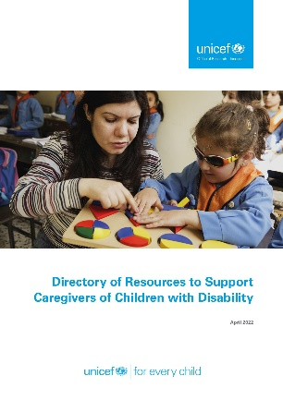
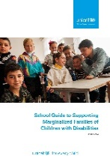
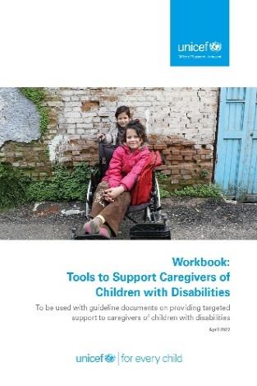
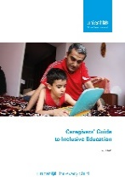
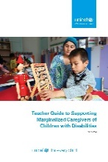
Guides for schools, teachers and caregivers of children with disabilities are the first documents of this series. These guides are intended to support caregivers to understand their rights, identify their needs and challenges, and find ways to come up with solutions.
The Workbook contains tools that can help you think more about and work on the questions raised in this guide. These tools will help you think about the specific solutions that caregivers may need and how schools and teachers can help them in the process.
The Directory of Resources has helpful materials, information and links. It is a useful first place for caregivers, teachers and schools to look for solutions to challenges they have identified. All the resources are free, although schools may help caregivers to print the materials.
The summary table on page 4 tells you what challenge, need and age group each resource is best suited for.

This Directory of Associations and Organizations has a list of local associations, organizations and networks that exist to connect and support parents and caregivers of children with disabilities. Some of them may be a good source for more information, ideas for solutions and ways to connect with others in similar circumstances.
EXAMPLE FROM ARMENIA

Bridge of Hope
Address: | Koryun str. 19a, Yerevan 0009, RA  4 Blbulyan str.,  lane.2, Ijevan, Tavush Marz, RA  15 Shahumyan str.,  Dilijan, Tavush Marz, RA  1 Zoravar Andranik str.,  Noyemberyan, Tavush Marz, RA  6a, Hayk Nahapet str.,  Berd, Tavush Marz, RA
Telephone: | +374 10 560143 (Yerevan)  +263 4 5616 (Ijevan)  +268 2 3650 (Dilijan)  +266 23670 (Noyemberyan)  +267 21975 (Berd)
Email: | info@bridgeofhope.am
Website: | https://bridgeofhope.am/
Description:
The mission of Bridge of Hope NGO is to protect the rights and dignity of children and youth with disabilities and their families and support their social inclusion in the Republic of Armenia. This includes promoting general inclusive education at all levels and active participation of parents in the education of their children.

EXAMPLE FROM UZBEKISTAN

Republican Center of Social Adaptation of Children with Disabilities
Address: | 34, A. Kakhar street, Tashkent, Uzbekistan
Telephone: | +998 71 281 59 31/32; +998 71 281 49 53  +998 71 281 49 54
Email: | rcsad@mail.ru  bolalar_markazi@exat.uz
Website: | http://rcsad.uz/
Description:
Providing comprehensive medical and social, psychological and pedagogical assistance and advisory and legal assistance to children with disabilities and their caregivers. Development of targeted comprehensive programs for children with disabilities. Monitoring the implementation of government programs and the development of proposals to improve the efficiency of the implementation of these activities. Training and retraining of specialists. Carry out analysis of the quality of teaching aids on the social adaptation of children and the development of proposals for their improvement.

The RCSAC has branches in the following regions:
- Ferghana
3, Obod street, Ferghana, Uzbekistan
Tel: (+998) 73 244-54-71
- Samarkand
58, A. Jomiy street, Samarkand, Uzbekistan
(+998) 66 233-28-10
- Kashkadarya
19, Afrosiyob street, Karshi, Uzbekistan
(+998) 75 224-14-65

Address:
Telephone:
Email:
Website:
Description:

Address:
Telephone:
Email:
Website:
Description:

Address:
Telephone:
Email:
Website:
Description:

Address:
Telephone:
Email:
Website:
Description:

Address:
Telephone:
Email:
Website:
Description:

Address:
Telephone:
Email:
Website:
Description:

Address:
Telephone:
Email:
Website:
Description:

Address:
Telephone:
Email:
Website:
Description:

Address:
Telephone:
Email:
Website:
Description:

