Appendix 2: Reporting form back to schools

Thank you for allowing us to assess the nutrition environment at your school. Below is a summary of the findings that relate to your schools and recommendations for improving your school nutrition environment.

Editable form:

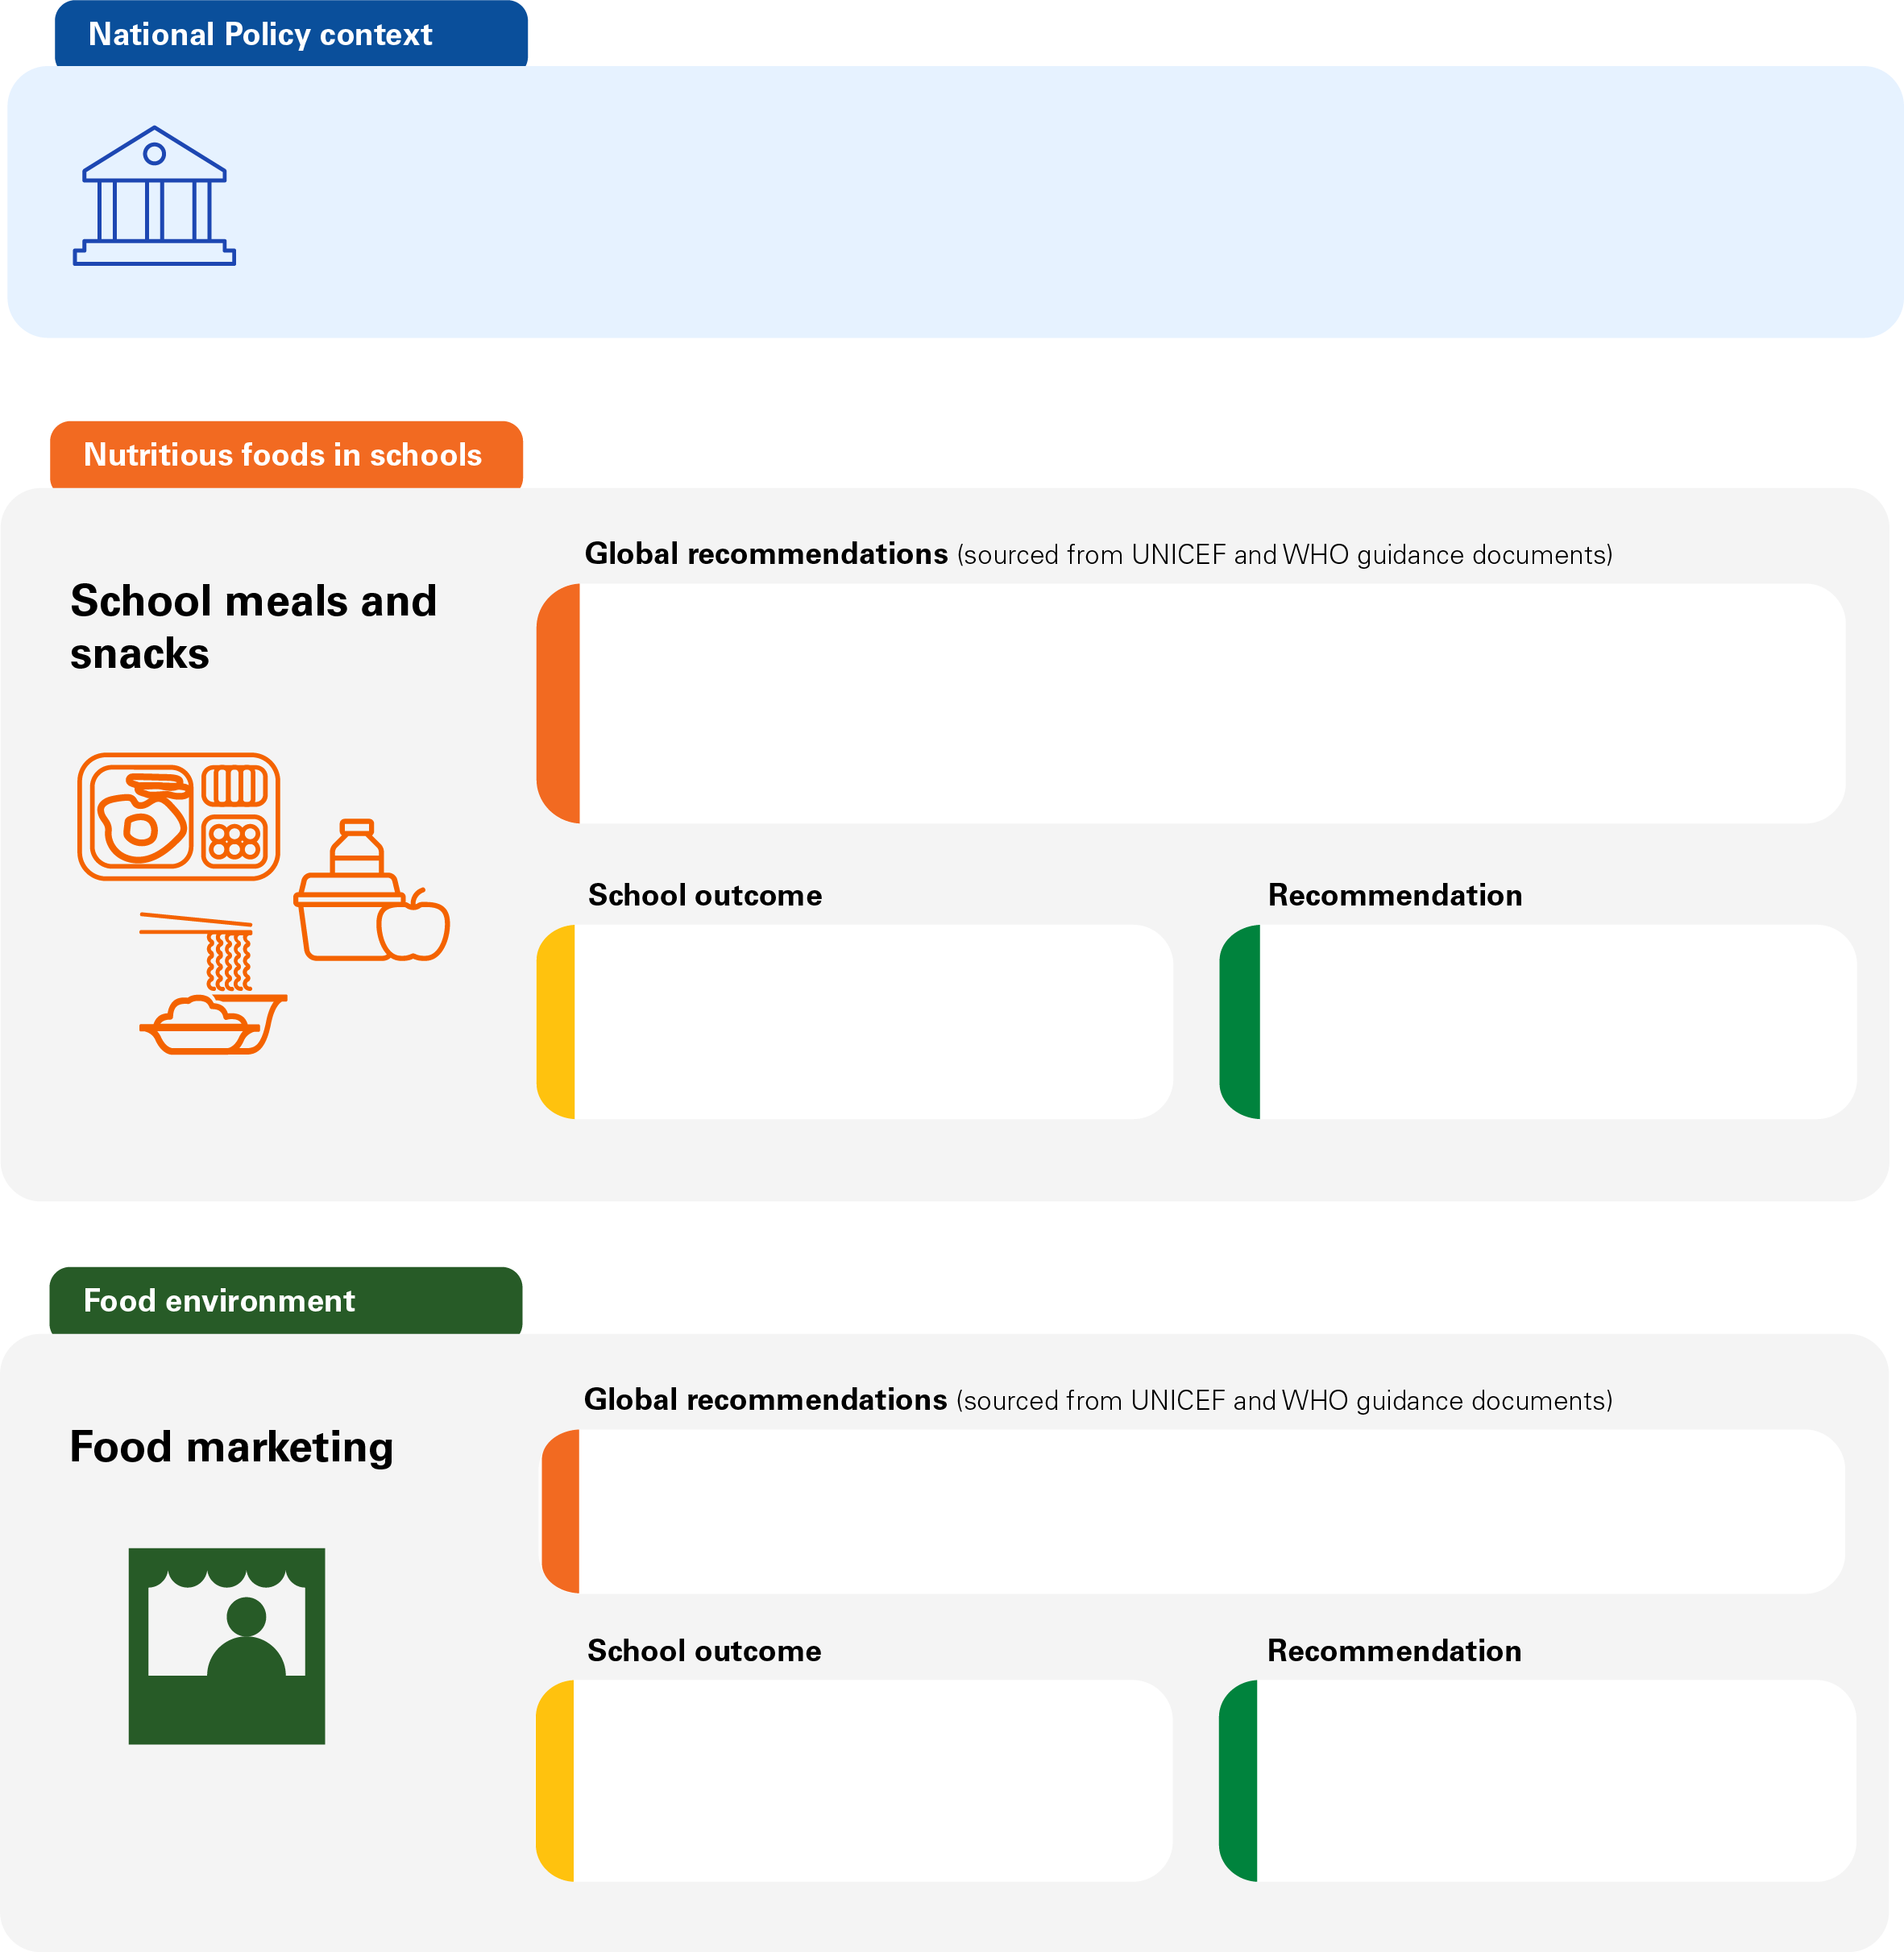
Type text here
Type text here
Type text here
Type text here
Type text here
Type text here
Type text here

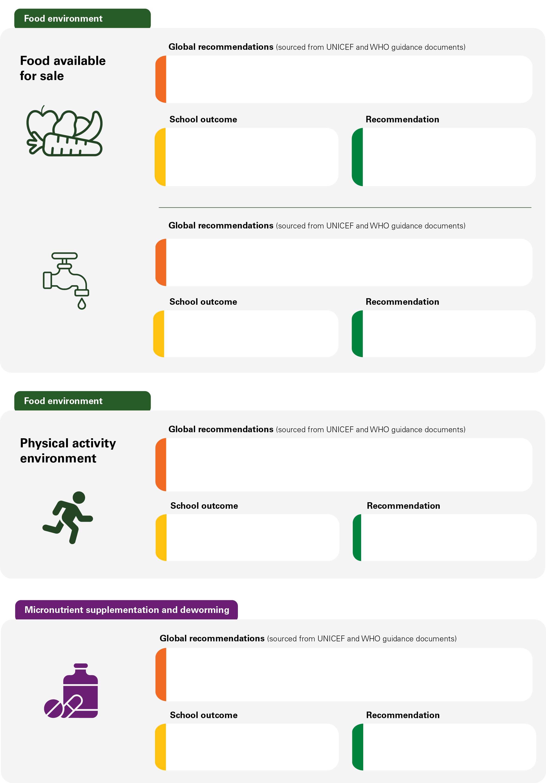
Type text here
Type text here
Type text here
Type text here
Type text here
Type text here
Type text here
Type text here
Type text here
Type text here
Type text here
Type text here
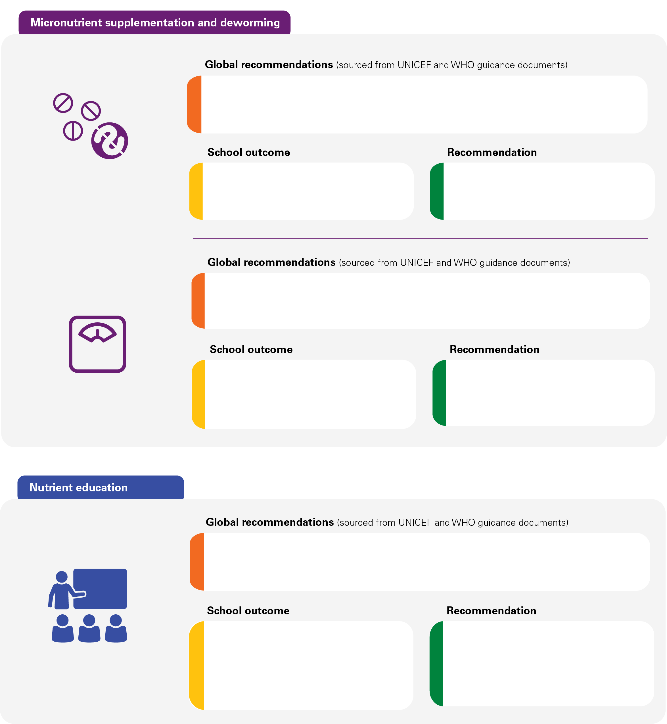
Type text here
Type text here
Type text here
Type text here
Type text here
Type text here
Type text here
Type text here
Type text here

